Housing Needs Advice for the
East Keswick Neighbourhood Plan
United Kingdom & Ireland

Table of contents | 1. INTRODUCTION 2  1.1 Housing needs assessment in neighbourhood planning 2  1.2 Study context 2  2. APPROACH 2  2.1 NPPG-based assessment 2  2.2 Summary of methodology 3  2.3 Gathering and using a range of data 3  2.4 Determining unconstrained demand 3  2.5 Study objectives 4  3. RELEVANT DATA 4  3.1 Local planning context 4  3.2 Local economic context 11  3.3 Characteristics of population 13  3.4 Household type 17  3.5 Household projections 18  3.6 Household tenure 19  3.7 Housing occupancy rates 21  3.8 Local household composition 21  3.9 Economic activity 3  3.10 Local survey work 5  4. CONCLUSIONS 7  4.1 Quantity of housing needed 7  4.2 Characteristics of housing needed 11  4.3 Recommendations for next steps 13

- INTRODUCTION
- Housing needs assessment in neighbourhood planning
The 2011 Localism Act introduced Neighbourhood Planning, allowing parishes or neighbourhood forums across England to develop and adopt legally binding development plans for their neighbourhood area.
As more and more parishes and forums seek to address housing growth, including tenure and type of new housing, it has become evident that emerging policies need to be underpinned by robust, objectively assessed data on housing need within the neighbourhood plan area.
In the words of the National Planning Policy Guidance (NPPG), establishing future need for housing is not an exact science, and no single approach will provide a definitive answer. The process involves making balanced judgements, as well as gathering numbers and facts. At a neighbourhood planning level, one important consideration is determining the extent to which the neighbourhood diverges from the local authority average, reflecting the fact that a single parish almost never constitutes a housing market on its own and must therefore be considered in its wider context.
The guidance quoted above on housing needs assessment is primarily aimed at local planning authorities preparing SHMAs. However, it helpfully states that those preparing neighbourhood plans can use the guidance to identify specific local needs that may be relevant to a neighbourhood, but that any assessment at such a localised level should be proportionate.
Our brief was to advise on data at this more local level to help East Keswick understand what its ‘fair share’ of the Leeds-wide housing requirement might be and how that might translate into local need for different types of housing.
- Study context
East Keswick is a village and civil parish within the jurisdiction of the City of Leeds, and lies approximately 3.5 miles south-west of Wetherby. The nearby A58 lies just short of a mile to the east of the village and connects it to Leeds in the south; and Wetherby, along with the A1(M) to the north.
East Keswick is considered for planning purposes part of the Leeds Strategic Housing Market area, sitting within the SHMA’s Outer North East’ sub-market area. As well as its close links to Leeds, East Keswick’s position close to the A1 corridor and proximity to Harrogate and York are likely to be relevant factors at a more local level. The Neighbourhood Plan area comprises the entire parish.
- APPROACH
- NPPG-based assessment
This housing needs advice note seeks to be objective but is not a full Housing Needs Assessment. The approach has been agreed with RTPI Planning Aid England and follows the NPPG approach where relevant. This ensures our findings are appropriately prepared. The NPPG advises that assessment of development needs should be thorough but proportionate and does not require planners to consider purely hypothetical future scenarios, only future scenarios that could be reasonably expected to occur.
- Summary of methodology
Our approach is to calculate a theoretical housing figure for East Keswick based on the Adopted Leeds Core Strategy (November 2014) figure, as a starting point. We then calculate a second theoretical housing need for East Keswick based on the latest Government household projections (2012) which are informed by the latest population projections. For further comparison, we have also examined the theoretical housing need figure arising from the 2008-based household projections, which were the projections used to inform the housing target in the Adopted Leeds Core Strategy, alongside a supply side projection based on the delivery of housing in the ten year period between the two censuses. It should be noted that the supply side projection has been provided for information and context purposes only – as the NPPG advises that supply side factors should not be considered in coming to a view on housing need. However we have considered this wide range of data in order to demonstrate compliance with the NPPG – see section 2.3 below.
Whilst it is our understanding that the Neighbourhood Group are not particularly interested in identifying a particular ‘target’ for housing provision in the Parish, and indeed are under no obligation to do so, we have provided this information because it provides a useful context for considering the characteristics of the types of housing which may be required. To address this issue, we have gathered a wide range of local evidence likely to apply to East Keswick’s particular circumstances. The local evidence has been designed to inform Parish Council decisions on the characteristics of housing, as well as the quantum of the housing required. This is important because the evidence may suggest that the characteristics of the housing required could be a factor influencing the overall level of housing needed.
- Gathering and using a range of data
The NPPG states that ‘no single source of information on needs will be comprehensive in identifying the appropriate assessment area; careful consideration should be given to the appropriateness of each source of information and how they relate to one another. For example, for housing, where there are issues of affordability or low demand, house price or rental level analyses will be particularly important in identifying the assessment area. Where there are relatively high or volatile rates of household movement, migration data will be particularly important. Plan makers will need to consider the usefulness of each source of information and approach for their purposes’.
It continues: ‘Plan makers should avoid expending significant resources on primary research (information that is collected through surveys, focus groups or interviews etc. and analysed to produce a new set of findings) as this will in many cases be a disproportionate way of establishing an evidence base. They should instead look to rely predominantly on secondary data (e.g. Census, national surveys) to inform their assessment which are identified within the guidance’.
In seeking to follow this approach, we noted that, compared with the 2001 Census, the 2011 Census gathered data in a number of new categories and across a range of geographies that are highly relevant to planning at the neighbourhood level.
Like much of the data that can build a picture of housing need, the Census information is quantitative. However, at a local level, qualitative and anecdotal data, if used judiciously, also has an important role to play, to a perhaps greater extent than at local authority level. Our approach has been to gather data from as wide a range of sources as practicable in order to ensure robustness of conclusions and recommendations arising from the analysis of that data.
- Determining unconstrained demand
Our approach is to establish unconstrained demand. This is in line with the NPPG, which states that ‘the assessment of development needs should be an objective assessment of need based on facts and unbiased evidence. Plan makers should not apply constraints to the overall assessment of need, such as limitations imposed by the supply of land for new development, historic under performance, viability, infrastructure or environmental constraints.’
For this reason, we advise that if the Parish do wish to consider setting a housing target in the neighbourhood plan (and it is our understanding that they do not), they should look to investigate available capacity as a separate and follow-on study. If the advice note indicates a greater quantum of housing is needed than there are suitable or available sites, then any site selection process may need to be revisited to determine if there is further land with the potential to meet demand.
If the advice note indicates a smaller quantum of housing is needed than there is suitable land available, then sites should be scored or ranked to indicate which are preferred for the development needed, with the remainder either discounted or safeguarded for future use as appropriate.
- Study objectives
The objectives of this housing needs advice note can therefore be summarised as:
- collation of a range of data with relevance to housing need in Leeds and East Keswick;
- analysis of that data to determine patterns of housing demand;
- setting out recommendations based on our data analysis that can be used to inform the Neighbourhood Plan’s housing policies.
The remainder of this report is structured around the objectives set out above:
- Chapter 3 sets out the data gathered from all sources; and
- Chapter 4 sets out our conclusions and recommendations.
- RELEVANT DATA
- Local planning context
Leeds Strategic Housing Market Assessment (SHMA) Update (GVA and Edge Analytics, May 2011)
The NPPG states that parish councils can refer to existing needs assessments prepared by the local planning authority as a starting point. We therefore turned first to the Leeds SHMA Update (2011) which is the most up-to-date housing needs assessment document for the entire Leeds City Council area, and informs the Core Strategy’s housing policies, including its affordable housing policy.
The SHMA draws upon a range of statistics including population projections, housing market transactions and employment scenarios to recommend an objectively-assessed housing need for the City. As such, it contains a number of points of relevance when determining the degree to which East Keswick’s housing needs context differs from the authority-wide picture. It divides Leeds into a number of sub-market areas for the purpose of analysis.
Tenure and type of local housing offer
East Keswick is located in the Outer North East sub-market area. The SHMA states that a clear arc of high levels of owner occupation is visible to the north and north east of the City area, and that those areas are also characterised as being primarily made up of semi-detached and detached properties.
Recent rates of housing growth
The SHMA includes a map showing net housing completions by sub-market area over the period 2001 to 2010, reproduced as Figure 1 below. Of the total of 27,755, the Outer North East provided 858 units, or 3% of this total. Note that East Keswick is in an area of relatively low completions over this period (less than five) relative to the rest of the Outer North East sub-market area, in particular Wetherby.

Figure 1: Net housing completions across Leeds City Council area, 2001 to 2010
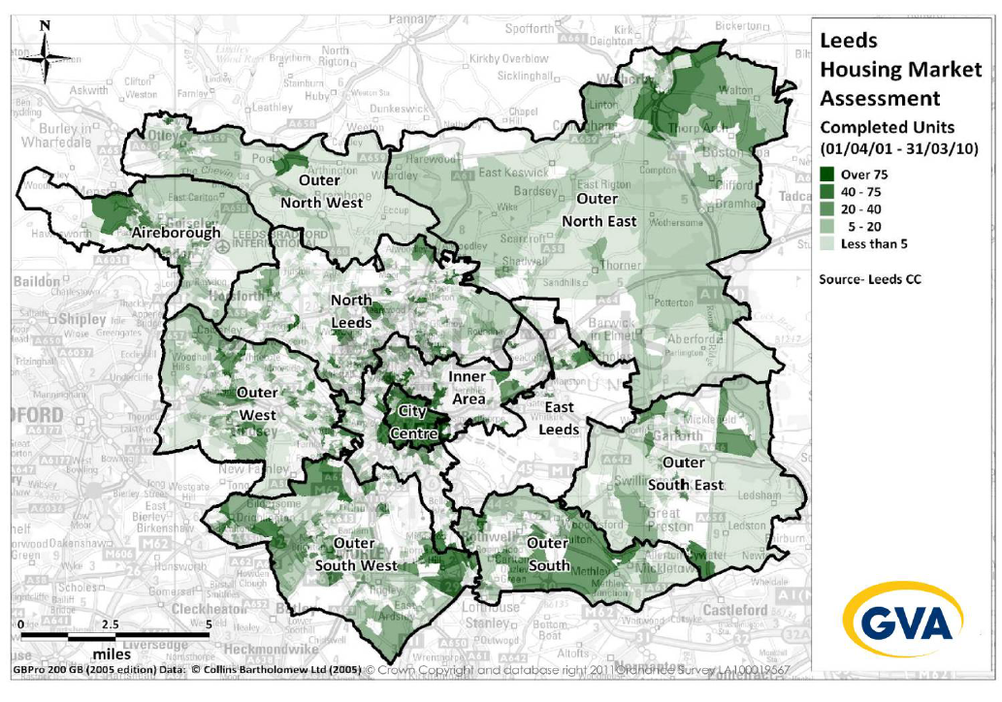
East
Keswick
Source: Leeds SHMA Update (GVA and Edge Analytics, May 2011)
The SHMA points out that at a sub-market area level the historic development trends have seen new supply concentrated in the city centre in particular. Under the trend-based scenarios this growth is projected to continue over the longer-term. In reality when considering the potential availability and deliverability of supply across the sub-market areas, the SHMA states it is clear that demand will need to be re-balanced. Whilst the city centre and inner areas will clearly continue to grow, other areas will also need to bring forward development in order to ensure a housing offer which matches demand.
Recent rates of housing demand
Also presented in the SHMA is a map showing house price change by sub-market area over the period 2006 to 2010, reproduced as Figure 2 below. Figure 2 suggests that East Keswick showed relatively high demand over this period, despite its proximity to a number of settlements experiencing declining house prices, including Boston Spa, Wetherby, Bramham, Thorner and Barwick in Elmet.

Figure 2: House price change across Leeds City Council area, 2006 to 2010
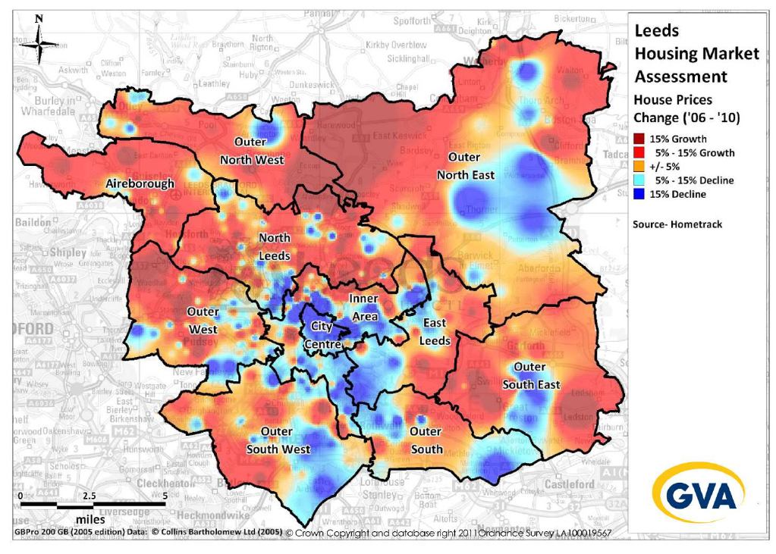
Source: Leeds SHMA Update (GVA and Edge Analytics, May 2011)
Overall projected rate of new household formation
Overall, the SHMA concludes that an employment-led scenario is the most robust projection to use. This results in a forecast of 4,500 new households being formed annually across Leeds over the Core Strategy period (to 2028). This household growth projection has been translated into a net dwelling requirement of approximately 4,680 per annum.
Projected size of new households being formed
The SHMA analysis suggests that Leeds is likely to see a continued growth in single person and couple households, with a relatively small rise in family households. The city is projected to increase its working age population significantly and also the number of households aged over 60.
The analysis also points to a rising demand for smaller properties based on the projected increase in couple and single person households. In total, it is estimated that 55% of demand for new stock will be for two bedroom properties. However, forecast increases in family households alongside a recognition of the aspirations of households and indeed a desire strategically to retain family households within Leeds (rather than foster a historic trend of out-migration) suggests that a healthy supply of larger three and four bedroom properties will also be required. The analysis suggests that 27% of demand will be generated for three bedroom properties with just under 10% being for properties with four bedrooms or more. Family households appear to prefer three or four bedroom properties (over 70% collectively).
The SHMA goes on to note that trends of out-migration from the main urban area of Leeds have primarily involved family households choosing to re-locate to seek better value for money in surrounding authorities and/or to benefit from the high quality of life demonstrated in markets to the north of the City. Clearly, these trends will have an impact on the types of properties that Leeds will need to develop to match projected household profiles and aspirations.
Projected age of head of households
The SHMA highlights growth in absolute and proportional terms of households aged 35 – 44 between 2010 and 2028. This household age group represents the age-band most likely to represent families. This has an impact both in terms of the size of the property required and also the importance of functional links between home and employment.
The SHMA also notes:
- Projected increase in the number and proportion of households where the head of household is over 65 with over half being couple households, and just under half single person households.
- Continued increase in households with head of household over 85 years old, placing increasing pressure on supported housing including Extra Care facilities. The SHMA states that delivering these schemes within the authority is becoming increasingly difficult as a result of reduction in public sector subsidy and there is a potential danger that supply will become increasingly out of line with growing demand.
The projections suggest that whilst there will be an increase in older person households, increasing employment opportunities and the influence of the large universities will continue to ensure a growth in younger households as well.
Households in priority need
Figure 3, reproduced from the SHMA, shows the spatial distribution of households classified as in priority need, which is Leeds City Council’s designation of those households needing new housing as soon as possible. In the Outer North East sub-market area, there are only 39 households in priority need, which is 1% of the Leeds total (of 3,326). It suggests that accommodating households classified as in priority need is not a significant housing issue in East Keswick itself.

Figure 3: Households in Priority Need across Leeds City Council Area, 2011
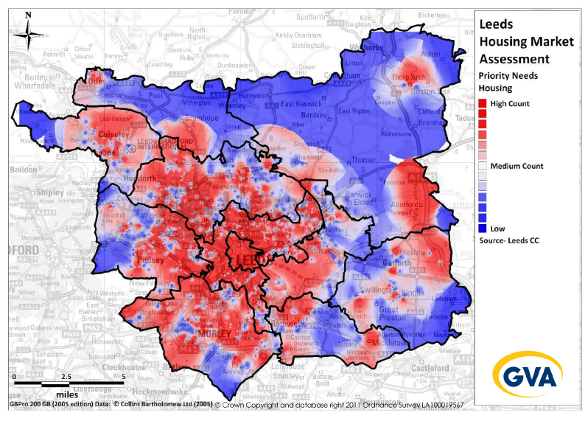
Source: Leeds Homes/Leeds City Council/GVA analysis, February 2011
Vacancy rates
The SHMA highlights a 5% vacancy rate across the city, but a rate of 4% in the outer northeast area based on 2010 council tax records. The standard assumption is a market should expect 3% vacancy to enable turnover. This would suggest that long-term vacancy is not a significant housing issue in East Keswick or its surrounding area.
SHMA Caveats
The SHMA dates from 2011, and is based on the data available at the time it was compiled. It points out:
- Leeds City Council should monitor changes in the housing market and the underlying drivers examined in the SHMA.
- Changes to the assumptions will have an impact on the short and long-term projections of household demand and the requirements for different tenures and sizes of housing.
- That there is no single definitive method available to attribute need for new market housing to specific geographical areas within Leeds. The various elements of population growth and household growth cannot be directly attributed to sub-market areas with anything near the same reliability that they can be attributed to Leeds as a district, which benefits from the cohesion of a single travel to work area. The precise geographic distribution of future housing was therefore left as a policy choice for Leeds’ Core Strategy.
This caveat applies equally for neighbourhood planners within the Leeds City Council area. As we recommend an approach based on the assessment of need at a local authority level, the Parish Council should monitor any updates to the assessment of housing need at a local authority level, as well as the release of relevant new statistics, for example updated population projections.
This is particularly the case given that since the introduction of the National Planning Policy Framework in 2012, local authorities are now required to base their housing targets on ‘objectively assessed need’, meaning that a SHMA produced before this requirement, as in the case of Leeds, has the potential to be considered out of date as a result. However, at the time of writing this advice note, the Local Plan Inspector had confirmed that he was satisfied to continue to use the housing target informed by the 2011 SHMA in Leeds’ case, and the Core Strategy was found sound and adopted on that basis.
Leeds City Council housing allocation (Core Strategy and Site Allocations DPDs)
Leeds City Council adopted its Core Strategy in November 2014. The housing target is identified as 70,000 new dwellings. The Inspector accepted (in his report of September 2014) that this target was based on the 2008-based population projections and did not reflect the 2012-based population projections, however he was convinced that the target of 70,000 was based on a robust assessment of the objectively assessed need for housing for Leeds.
The Publication Draft of the Site Allocations DPD is due to be published in the Summer/Autumn of this year. In February 2015, the Council agreed in principle the sites which should be allocated for housing. There are no sites identified within the East Keswick parish boundary.
The Core Strategy and Site Allocations documents take the SHMA conclusions and use them to inform an overall housing allocation target of 66,000 net new houses over the plan period to 2028.
In addition, Policy H5 Affordable Housing sets out targets for delivery of affordable housing, based on certain market zones. East Keswick is located in Affordable Housing Market Zone 1. Within this zone the policy sets a target of 35% affordable housing to be provided on new developments above a threshold of 10 units. For housing schemes below the on-site size thresholds in Zone 1, an offsite commuted sum will be sought. For on-site schemes, the affordability of affordable housing should be designed to meet the identified needs of households as follows;
- 40% affordable housing for households on lower quartile earnings;
- 60% affordable housing for households on lower decile earnings.
The affordable units should be a pro-rata mix in terms of sizes and types of the total housing provision, unless there are specific needs which indicate otherwise.
The Site Allocations document states that sites comprising existing unbuilt housing allocations or other sites with unimplemented permissions for housing can be removed from the target of 66,000, and across Leeds as a whole this equates to an existing supply of 31,933 dwellings. However, none of these sites are within the boundaries of East Keswick parish, as confirmed by Leeds City Council site allocation mapping, meaning our calculations must aim to determine East Keswick’s share of the 66,000 figure.
Neither the Core Strategy nor the Site Allocations document set a specific housing allocation for East Keswick. However, AECOM has analysed available data to generate the proportion of the 66,000 net new houses that might reasonably be expected to be provided by East Keswick parish. This exercise provides East Keswick with a starting point figure that can be regarded as its ‘theoretical share’ of housing within the overall Leeds City planning context. We then go on to test this nominal figure against more local demographic, economic and housing market analysis.
The 66,000 new houses to be provided within the Core Strategy period have been distributed according to a settlement hierarchy, as illustrated in Table 1 below.
Table 1: Settlement types identified in Leeds Core Strategy for the purposes of housing distribution
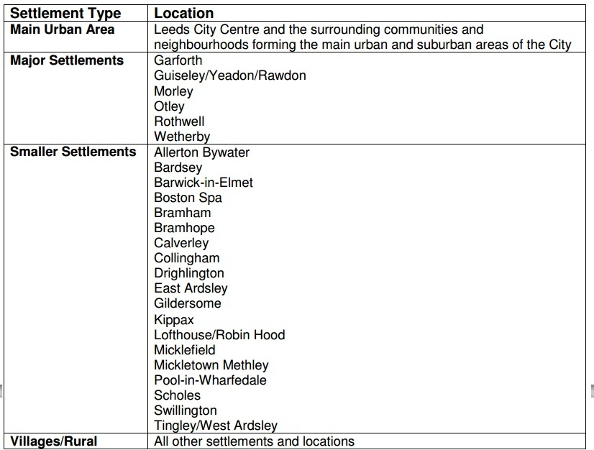
Source: Leeds City Council Core Strategy, 2013 (and carried forward into the 2014 version)
Leeds City Council area is divided into a non-parished area comprising the more urban part of the local authority and a number of parishes comprising smaller settlements and the villages/rural classification. East Keswick is designated as a Parish and is categorised in this villages/rural section.
The Core Strategy allocates the villages/rural classification 700 of the 66,000 dwellings. There are fifteen smaller settlements, giving a nominal figure of 46.7 dwellings per settlement (700 divided by 15).
We have measured the population of each of the villages/rural parishes using Census data, wherever possible on a parish population basis. In so doing, we calculate that each village has an average population of 850, meaning one dwelling per 18 people.
This average figure can then be made more accurate by taking into account the Census 2011 population of each village/rural settlement on the assumption that larger settlements need more housing to meet the needs of a larger population and they offer more services and facilities, thus ensuring development patterns accord with the principles of sustainable development.
On this basis, East Keswick, with a population of 1146, could be expected reasonably to accommodate an estimated 24.5 units over the Core Strategy period. Of this figure of 24.5 units, in line with the Core Strategy aspirations for development on previously developed land, 3.5 are projected to be infill and 21 on previously undeveloped land.
It should be emphasised that the figure of 24.5 units is not an obligation for East Keswick. There is no statutory requirement for East Keswick to deliver any specific amount of new housing, as it is simply one of many settlements covered by the Villages/Rural Areas housing target. Rather, this figure has been calculated as the first of a number of theoretical figures of approximate housing delivery expectation for East Keswick. The theoretical figure reflects East Keswick’s population and all Leeds SHMA and Core Strategy work and verification carried out so far. It takes no account of East Keswick’s particular geographic and economic circumstances, which could also reasonably be expected to influence local housing needs, and which will be assessed in more detail later in this housing needs advice note.
Local housing waiting list (Leeds City Council, March 2014)
Leeds City Council has provided the housing waiting list figures for East Keswick and the Outer North East area of the City of Leeds, within which East Keswick sits, as of 13th March 2015. The total number of households on the Outer North East waiting list for Leeds is 317, whilst East Keswick Parish’s total is 5. This figure is broadly comparable with the Leeds affordable housing requirement of 35% of the theoretical share of 24.5 units (previous page), which is 8.5 units.
However, the SHMA states that ‘waiting lists tend to overestimate demand as households put themselves forward when their level of ‘need’ for affordable housing is not actually that great. For example, households may put themselves forward for inclusion as a form of insurance in case their circumstances change and are therefore clearly not currently in ‘need’ in a priority sense.’
To compensate for this, the SHMA defines those households on the waiting list as in priority need only if they fall into Bands A and B, and discounts those in Band C. Discounting the houses in the Outer North East waiting list in Band C gives us a revised total of 40 households in priority need for the Outer North East, of which 1 is accounted for by East Keswick (2.5%).
This revised figure of 1 household suggests there is no evidence of need for East Keswick to seek to raise the minimum affordability threshold beyond 35% of the new units to be provided over the Plan period (although this may not necessarily be the case for other parishes or neighbourhoods elsewhere in Leeds).
Wider planning context
In March 2014, Savills reported on the so-called ‘Yorkshire Golden Triangle’, comprising a high value property market between Leeds, Harrogate and York, which includes East Keswick. It states the area suffers from high demand and low supply, as it is popular with commuters. Savills state that local planning authorities have sought to retain their previous housing targets in response, with the exception of Selby, which has sought a lower figure.
This is of relevance to East Keswick as if housing supply is being constrained in Selby, spill-over demand is likely to impact on the Outer North East part of Leeds City Council’s area and the rest of the ‘Golden Triangle’.
- Local economic context
The NPPG states that housing market assessment should take employment trends into account. This is to ensure that any conclusions on housing need take into account the likely change in job numbers based on past trends or economic forecasts as appropriate and also have regard to the growth of the working age population in the housing market area. In the case of East Keswick, we have taken into account the relevant Strategic Economic Plan and Employment Land Review update, both comprising economic forecasts.
Strategic Economic Plan (Leeds City Region Enterprise Partnership, 2014)
For purposes of economic planning, East Keswick lies within the Leeds City Region Enterprise Partnership area and is therefore subject to the 2014 Strategic Economic Plan (SEP).
Like all economic plans and strategies, the Leeds City Region SEP seeks generally to grow and promote the local economy. What is important for the purpose of this housing needs advice, however, is to uncover the specific forecasts and/or projections within this strategic aspiration that are most likely to have an impact on East Keswick Parish and its immediate surroundings.
The SEP sees the future arrival of HS2 to Leeds as a key driver of its attractiveness as a business location, significantly enhancing its connectivity to Birmingham and London. However, it recognises that this is currently scheduled as the last phase of HS2, not taking place until 2027 and in the meantime, Birmingham and Manchester will already be connected.
It also highlights Leeds’ recent strength relative to the rest of the North when it notes that the City Region was the only one in the North to show export growth in 2013.
The SEP also notes:
- the working age population is set to grow faster than the national average;
- there is an aspiration for Leeds to become the ‘nerve centre for the North’s knowledge economy’;
- City Region employment has recovered to better than pre-recession levels;
- key industry sectors include financial and professional services, health and life sciences, innovative manufacturing, creative and digital, food and drink and low carbon/environmental;
- there is an aspiration for 62,000 extra jobs by 2021 making the City Region economy 25% larger than it is at present (though current forecasts suggest 50,000 extra jobs);
- the polycentric nature of the City Region, with York as a strategic growth centre alongside Leeds; and
- the Aire Valley Leeds enterprise zone, with thousands of new jobs planned in a location just a few junctions along the A1/M1, to the east of East Keswick.
However, the SEP is an aspirational document used to bid for funds and has not been fully tested at examination, so any figures and facts collated from it should be used cautiously.
Leeds Employment Land Review 2010 Update (Leeds City Council, 2011)
The Employment Land Review Update quotes the Yorkshire Futures Regional Econometric Model as showing the five fastest growing sectors of the Leeds economy to be business services, construction, health, retailing and transport.
Figure 4 below is reproduced from the Employment Land Review Update and sets out total employment by the three main sectors of employment land.

Figure 4: Total employment in office, industrial and warehousing sectors, Leeds 1986-2026 (actual and forecast)
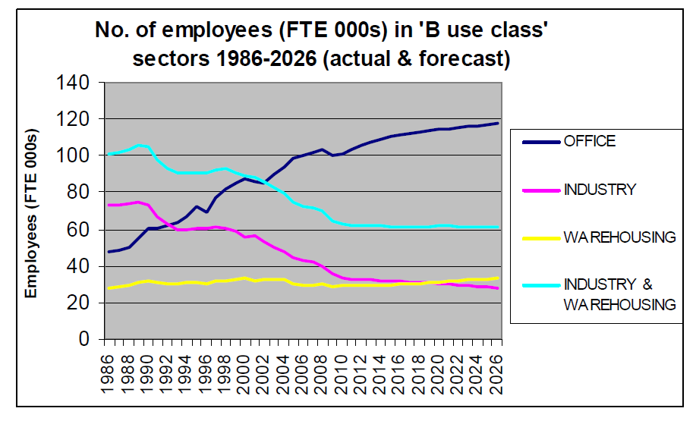
Source: Leeds City Council, Leeds Employment Land Review Update (2011)
Relevant points for East Keswick from the Employment Land Review include the following:
- From a 2010 base date; office employment will increase by 16,400 by 2026, industrial employment will fall by 3,700 and warehouse employment will increase by 4,300.
- Overall the regional economic model forecasts a net 17,000 increase in full time equivalent employment in the B-class uses (business, industry and distribution) in Leeds by the end of the study period.
- Within the Outer North East (i.e. the location of East Keswick), no net loss of employment land is proposed, with the existing 26.6 hectares to be carried forward into the future and this is the only sector of Leeds City where this is the case.
- the contribution of the Aire Valley Leeds AAP to the city’s strategic employment land supply is likely to be significant over the course of the plan period; Table 22 of the Employment Land Review suggests that Aire Valley will provide 77.1 hectares of land for the office sector.
To summarise, the Employment Land Review suggests that East Keswick is geographically and demographically well-situated for forthcoming employment development across Leeds, including office development at Aire Valley within the A1/M1 corridor.
- Characteristics of population
Through analysis of Census 2011 data available at parish level, we have investigated how the population of East Keswick differs from that of the Leeds and the England average.
East Keswick has an older population in the 2011 Census than the Leeds and England average, as illustrated in Figure 5 below. The largest age group in the parish is ages 45-64, at 33.9%. The second biggest group is ages 25-44, but at 19.6% this is significantly smaller than across Leeds, where 25-44 is the largest age group comprising 28.7% of the total population. East Keswick also has a smaller proportion of residents aged 16-24 than Leeds (8.9% compared with 15.4%), and a considerably larger proportion of residents aged 65-84 (19.0% compared with 12.6%).

Figure 5: Population age bands in East Keswick, 2011
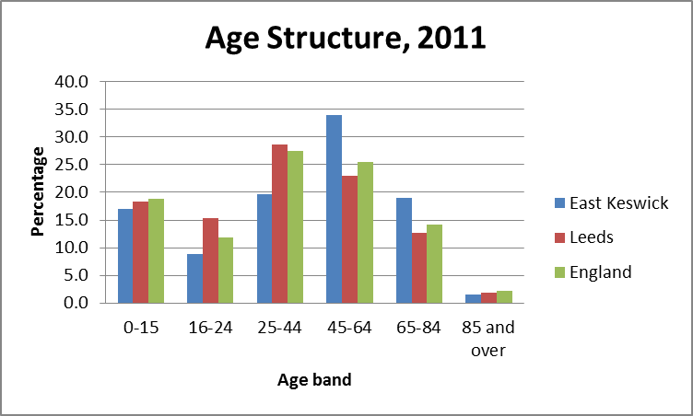
Source: ONS (2012) Census 2011
Table 2 shows the rate of change of the population by age band. It shows that the rate of growth of people aged 65-84 in East Keswick between 2001 and 2011 significantly exceeded both the Leeds and the national average, presumably as a result of people ageing in place within the parish, or of people moving to the parish. There was a sharper than average decrease in people aged 85 and over, however this growth equates to very small numbers of people: there were 20 people aged over 85 living in the parish in 2001, and 17 in 2011.
Between 2001 and 2011 there was a steep decline in children aged 0-15 and people aged 25-44, but an increase in young people aged 16-24. This suggests that families already living in the parish have aged in place and that fewer young families have moved into or formed within the parish over this period.
Table 2: Rate of change in the age of population in East Keswick, 2001-2011
 | % change, 2001-2011
 | East Keswick | Leeds | England
0-15 | -87.2% | -3.9% | 1.2%
16-24 | 15.9% | 18.6% | 17.2%
25-44 | -24.5% | 3.6% | 1.4%
45-64 | -0.8% | 10.1% | 15.2%
65-84 | 32.1% | -1.0% | 14.4%
85 and over | -15% | 7.4% | 23.7%

Source: ONS, Census 2011 and Census 2001, AECOM calculations

Table 3: Country of birth in East Keswick, 2011
 | East Keswick | Leeds | England
England | 90.1% | 86.2% | 83.5%
Northern Ireland | 0.3% | 0.5% | 0.4%
Scotland | 2.6% | 1.4% | 1.3%
Wales | 1.35 | 0.5% | 1.0%
UK not otherwise specified | 0.0% | 0.0% | 0.0%
Ireland | 0.1% | 0.6% | 0.7%
Other EU (in March 2001) | 1.1% | 1.1% | 1.7%
Other EU (accession since 2001) | 0.6% | 1.6% | 2.0%
Other | 3.8% | 8.1% | 9.4%
Source: ONS (2012) Census 2011

Table 4: Length of residence in the UK in East Keswick, 2011
 |  | East Keswick | Leeds | England
Born in the UK |  | 94.3% | 88.5% | 86.2%
Born outside of the UK: total |  | 5.7% | 11.5% | 13.8%
Born outside of the UK - length of residence | Less than 2 years | 0.4% | 14.3% | 12.6%
Born outside of the UK - length of residence | 2-5 years | 1.1% | 18.2% | 16.0%
Born outside of the UK - length of residence | 5-10 years | 1.0% | 23.9% | 20.7%
Born outside of the UK - length of residence | 10 years or more | 3.2% | 43.6% | 50.7%
Source: ONS (2012) Census 2011

Tables 3 and 4 show that East Keswick is home to significantly fewer migrants, both from the EU and beyond, than the Leeds and England averages. The figures for migration from Wales, Scotland and Northern Ireland are slightly higher than the local and national averages, but it is reasonable to suggest that local demand is driven by those born in England to a far greater degree than other population groups. Of the 65 East Keswick residents born overseas, more than half have lived in the UK for ten years or more. This data shows that recently higher rates of international migration, including from the EU accession countries from 2004, have had relatively little impact on East Keswick.
Census 2011 data on ethnic origin shows that East Keswick’s residents are 97.1% white and only 2.9% black and minority ethnic (BME). The sometimes differing housing needs of minority populations, which can play a significant role in housing need assessment in some locations, are therefore not considered to be of relevance to East Keswick.
The Office for National Statistics provides sub-national population projections at a local authority level, but no lower. These projections are set out in Table 5 below.

Table 5: ONS sub-national population projections (notional extrapolation to East Keswick)
 | East Keswick | Leeds |  | England
 | East Keswick | Population | Growth factor | Population | Growth factor
2012 | 1,156 | 758,000 |  | 53,494,000
2013 | 1,165 | 764,000 | 0.8% | 53,844,000 | 0.7%
2014 | 1,174 | 770,000 | 0.8% | 54,228,000 | 0.7%
2015 | 1,184 | 776,000 | 0.8% | 54,613,000 | 0.7%
2016 | 1,193 | 781,000 | 0.6% | 55,020,000 | 0.8%
2017 | 1,200 | 786,000 | 0.6% | 55,415,000 | 0.7%
2018 | 1,208 | 792,000 | 0.8% | 55,812,000 | 0.7%
2019 | 1,217 | 796,000 | 0.5% | 56,198,000 | 0.7%
2020 | 1,223 | 801,000 | 0.6% | 56,582,000 | 0.7%
2021 | 1,231 | 805,000 | 0.5% | 56,962,000 | 0.7%
2022 | 1,237 | 809,000 | 0.5% | 57,338,000 | 0.7%
2023 | 1,244 | 814,000 | 0.6% | 57,706,000 | 0.6%
2024 | 1,251 | 819,000 | 0.6% | 58,073,000 | 0.6%
2025 | 1,259 | 824,000 | 0.6% | 58,431,000 | 0.6%
2026 | 1,267 | 829,000 | 0.6% | 58,781,000 | 0.6%
2027 | 1,274 | 835,000 | 0.7% | 59,124,000 | 0.6%
2028 | 1,283 | 840,000 | 0.6% | 59,459,000 | 0.6%
Total change, 2012-2028 | 128 | 71,000 | 9.0% | 5,287,000 | 9.9%
Source: ONS (2014) 2012-based subnational population projections
The 2012-based projections (the most recent available) forecast a population growth of 71,000 people for Leeds City Council’s area up to 2028, which equates to a growth rate of 9.0%. This is slightly lower than the England average of 9.9%.
Taking this growth rate and applying it to the 2012 estimated population for East Keswick equates to an increase of 128 people to 2028, in other words from a 2012 population of 1,156 to a nominal 2028 population of 1,283. In order to understand how many homes this might entail we need to analyse household size growth figures over the plan period.

- Household type
Table 6: Rates of change in number of rooms per household in East Keswick, 2001-2011
 | % change, 2001-2011
 | East Keswick | Leeds | England
1 Room | N/A | -25.4% | -5.2%
2 Rooms | -16.7% | 44.0% | 24.2%
3 Rooms | -21.1% | 33.3% | 20.4%
4 Rooms | -10.0% | 0.8% | 3.5%
5 Rooms | -21.9% | -3.2% | -1.8%
6 Rooms | -3.4% | -1.7% | 2.1%
7 Rooms | 8.8% | 14.3% | 17.9%
8 Rooms or more | 6.2% | 29.5% | 29.8%
Source: ONS (2012) Census 2011

Table 6 shows that although the number of rooms per household has shown a generally upward trend, this has not been as significant in East Keswick as it has been locally and nationally. The proportion of households with seven or more rooms has grown, but at a lower rate than across Leeds and England. Conversely, there has been a sharper than average decrease in households with four, five or six bedrooms. It could be tentatively concluded that this shift from medium to larger-sized properties is to cater for the needs of families that are growing and ageing in place within the parish, as suggested above.
There has also been a decrease in households with two or three rooms, compared with a sharp increase locally and nationally. However, this relates to very small numbers of households. The data underlying this table shows that 205, or 43.5%, of households in East Keswick have eight or more rooms (compared with 9.7% in Leeds and 29.5% across England), whereas there are only 20 households in the parish that have two or three rooms (4.2% of the total, compared with 14.7% in Leeds and 13.2% across England).
Table 7: Trends in number of persons per room in East Keswick, 2001-2011
 | East Keswick | Leeds | England
Up to 0.5 persons per room | 2.0% | 8.77% | 7.90%
Over 0.5 and up to 1.0 persons per room | -17.3% | 0.02% | 6.99%
Over 1.0 and up to 1.5 persons per room | N/A | 9.34% | 27.29%
Over 1.5 persons per room | N/A | 8.83% | 2.54%
Source: ONS, Census 2011 and Census 2001, AECOM calculations

The NPPG states that factors such as overcrowding, concealed and sharing households, homelessness and the numbers in temporary accommodation demonstrate un-met need for housing. Longer term increase in the number of such households may be a signal to consider increasing planned housing numbers.
Table 7 indicates that overcrowding does not seem to be an issue in East Keswick, and households indeed became less crowded between 2001 and 2011. The number of households with up to 0.5 persons per room has increased slightly, although at a lower rate than the Leeds and England averages, and while there have been increases in households with between 0.5-1 persons per room both nationally and locally, in East Keswick these have declined sharply.

- Household projections
2012-based
The Department for Communities and Local Government (DCLG) publishes household projections which are based on the sub-national population projections interrogated above. The most recent 2012-based household projections were published in February 2015, and extend to 2037.
The NPPG recommends that these household projections should form the starting point for the assessment of housing need. However they are only available at a local authority level, limiting their use for neighbourhood planning.
Nevertheless, a calculation of theoretical share for East Keswick is possible based on household numbers in 2012 (the Core Strategy base date).
In 2012, Leeds City Council had 325,000 households. Based on its proportion of all Leeds households at the 2011 Census (0.147%), East Keswick would notionally have had 478 in that year. By 2028, DCLG projects 367,000 households for Leeds. On the theoretical assumption that East Keswick’s proportion of the Leeds total remains 0.147%, its new total number of households would be 540 and therefore 62 new households would have formed over the Core Strategy period.
In the 2011 Census, East Keswick parish had 488 dwellings and 471 households, giving a ratio of 0.965 households per dwelling. If this ratio is applied to the theoretical assumption of 62 new households in East Keswick by 2028, it translates to 60 new dwellings.
This figure is 35% higher than the theoretical calculated share of 24.5 dwellings, based on the Leeds Core Strategy target.
2008-based (rebased to 2012)
2008-based household projections were published in 2010, extending to 2033, and offer a useful comparator to the analysis above. They were also the projections that were used to inform the Adopted Leeds Core Strategy housing target.
The methodology for calculating household projections has subsequently been updated to incorporate information from the 2011 Census, and the 2008-based projections show a higher rate of growth than more recent projections, such as the 2012-based projections set out above.
In 2012, Leeds City Council had 325,000 households. Based on its proportion of all Leeds households at the 2011 Census (0.147%), East Keswick would notionally have had 478. By 2028, the 2008-based projections estimate 447,000 households for Leeds. On the theoretical assumption that East Keswick’s proportion of the Leeds total remains 0.147%, its new total number of households would be 657 and therefore 179 new households would have formed over the Core Strategy period.
In the 2011 Census, East Keswick parish had 488 dwellings and 471 households, giving a ratio of 0.965 households per dwelling. If this ratio is applied to the theoretical assumption of 179 new households in East Keswick by 2028, it translates to 173 new dwellings.
The above calculations give two alternative figures for the same plan period, 60 and 173. These figure are both significantly higher than the theoretical calculated share of 24.5 dwellings, based on the Leeds Core Strategy target.
However as identified above, the 2008-based projections predicted a much higher rate of household growth than more recent projections which are informed by the 2011 Census (the 2012-based projection is only 60 dwellings, which is less than half of the 2008-based calculations).
It should also be noted that these unconstrained figures comprise a relative proportion of the overall projected increase. They do not take into account political or any other drivers (such as supply constraints – including the location of East Keswick and other similar rural villages which are inset within the Green Belt) that might have influenced the Core Strategy distribution, and hence the difference between these unconstrained figures and the Core Strategy-based delivery figure.

- Household tenure
The NPPG states that housing needs studies should investigate household tenure in the current stock and in recent supply, and assess whether continuation of these trends would meet future needs. Plan makers should therefore examine current and future trends in tenure.
Table 8: Tenure (households) in East Keswick, 2011
 | East Keswick | Leeds | England
Owned; Total | 85.6% | 58.2% | 63.3%
Owned; Owned Outright | 46.7% | 26.0% | 30.6%
Owned; Owned with a Mortgage or Loan | 38.9% | 32.2% | 32.8%
Shared Ownership (Part Owned and Part Rented) | 0.0% | 0.4% | 0.8%
Social Rented; Total | 5.5% | 22.0% | 17.7%
Social Rented; Rented from Council (Local Authority) | 5.1% | 16.9% | 9.4%
Social Rented; Other Social Rented | 0.4% | 5.1% | 8.3%
Private Rented; Total | 7.9% | 17.9% | 16.8%
Private Rented; Private Landlord or Letting Agency | 7.2% | 16.7% | 15.4%
Employer of a household member | 0.2% | 0.1% | 0.3%
Friend or relative of a household member | 0.2% | 0.9% | 0.9%
Private Rented; Other | 0.2% | 0.2% | 0.3%
Living Rent Free | 1.1% | 1.5% | 1.3%
Source: ONS (2012) Census 2011

Table 8 show that levels of owner occupation in East Keswick significantly exceed the Leeds and England averages. This is particularly the case in terms of housing that is owned outright, without a mortgage or loan, perhaps reflecting the high proportion of the population in older age categories. The rate of social rented housing is considerably lower than either the Leeds or England averages, but the social rented housing that exists is almost all council housing. There is also a far smaller proportion of households in privately rented units than across Leeds and England.
Table 9: Rate of tenure change in East Keswick, 2001-2011
 | % change, 2001-2011
 | East Keswick | Leeds | England
Owned; Total | -6.1% | -0.6% | -0.6%
Owned; Owned Outright | 20.2% | 12.2% | 13.0%
Owned; Owned with a Mortgage or Loan | -25.6% | -8.0% | -9.1%
Shared Ownership (Part Owned and Part Rented) | N/A | 11.6% | 30.0%
Social Rented; Total | 0.0% | -7.5% | -0.9%
Social Rented; Rented from Council (Local Authority) | -7.7% | -14.2% | -23.0%
Social Rented; Other Social Rented | N/A | 25.2% | 47.3%
Private Rented; Total | 37.0% | 87.8% | 82.4%
Private Rented; Private Landlord or Letting Agency | 126.7% | 111.8% | 89.1%
Employer of a household member | -66.7% | -6.7% | 3.0%
Friend or relative of a household member | -66.7% | 83.3% | 60.1%
Private Rented; Other | -83.3% | -79.8% | -1.3%
Living Rent Free | N/A | -33.5% | -29.6%
Source: ONS (2012) Census 2011

Table 9 shows how tenure changed in East Keswick between the 2001 and 2011 censuses. Overall, homeownership saw a steeper decline than locally and nationally, but the number of households that are owned outright rose significantly. The number of owner-occupied households that are owned with a mortgage or loan, however, fell more sharply in East Keswick than in Leeds or England, while the number of privately rented households in the parish grew markedly, albeit at a slower rate than across Leeds and England. These factors point to fairly strong demand for East Keswick as a residential location, but suggest that relatively few new owner occupier households were able to move to or form within the parish over this period.
There was no change in the number of households in East Keswick living in socially rented properties over this period, despite the decrease recorded across both Leeds and England. There was a minor shift of two households from social housing rented from the council to social housing rented from other providers. Both Leeds and England have seen a sharp fall in the amount of social housing rented from councils, and a notable increase in households renting from other providers, such as housing associations or registered social landlords (RSLs).
We can analyse the rental sector in more detail using data from the home.co.uk website. This provides, for each postcode area and county, data on average price of rented property (adjusted for local range of housing type to enable like-for-like comparison), and data on average time that a rental property has been on the market. It can be assumed that the higher average rental price and shorter the average time on the market, the higher local demand for rental property, and by implication, the higher the local demand for owner-occupied stock as many prospective home-owners will rent if they cannot yet afford to buy.
Postcode area LS17 covers East Keswick as well as Alwoodley, Bardsey, Eccup, Harewood, Moortown, Shadwell, Weardley and Wike. The LS postcode area covers the whole of Leeds and the generally affluent area to its north, and is a fairly close approximation to the Leeds City Council area.

Table 10: Rental sector statistics in LS17 (including East Keswick) versus LS average
Postcode area | LS17 | LS | LS17 difference
Average rent per calendar month (£) | 929 | 864 | +7.5%
Average time on market (days) | 53 | 193 | -72.5%
Source: home.co.uk market rent summary, calculated daily, accessed March 2015
The price of rented property in LS17 is higher than the LS average, indicating high levels of demand for rental stock. This is supported by the average time on the market for rental properties in the area: properties in LS17 rented on average 72.5% faster than properties across the Leeds postcode area.
- Housing occupancy rates
AECOM attempted to source up-to-date council tax data from Leeds City Council to show housing occupancy and vacancy rates. However, none was available at the time of writing. On the basis of the Census and other data that we have sourced and presented above, however, it seems more likely than not that long-term housing vacancy rates in East Keswick are low, and as such do not form a relevant consideration for the purposes of this housing needs advice.

- Local household composition
Table 11: Household composition (by household) in East Keswick, 2011
 |  | East Keswick |  | Leeds |  | England
 |  | Number | % of total | Number | % of total | Number | % of total
One person household | Total | 101 | 21.4% | 106739 | 33.3% | 6666493 | 30.20%
One person household | Aged 65 and over | 52 | 11.0% | 38326 | 12.0% | 2725596 | 12.40%
One person household | Other | 49 | 10.4% | 68413 | 21.3% | 3940897 | 17.90%
One family only | Total | 358 | 76.0% | 186547 | 58.2% | 13631182 | 61.80%
One family only | All aged 65 and over | 63 | 13.4% | 22346 | 7.0% | 1789465 | 8.10%
One family only | Married couple
One family only | Total | 236 | 50.1% | 94982 | 29.6% | 7298680 | 33.10%
One family only | No dependent children | 95 | 20.2% | 35953 | 11.2% | 2691927 | 12.20%
One family only | One dependent child | 42 | 8.9% | 17265 | 5.4% | 1285267 | 5.80%
One family only | Two or more dependent children | 71 | 15.1% | 26527 | 8.3% | 2087738 | 9.50%
One family only | All children non-dependent | 113 | 24.0% | 15237 | 4.8% | 1233748 | 5.60%
One family only | Same-sex civil partnership
One family only | Total | 2 | 0.4% | 379 | 0.1% | 30775 | 0.10%
One family only | No dependent children | 2 | 0.4% | 322 | 0.1% | 27283 | 0.10%
One family only | One dpnt child | 0 | 0.0% | 32 | 0.0% | 1617 | 0.00%
One family only | Two or more dpnt children | 0 | 0.0% | 18 | 0.0% | 1268 | 0.00%
One family only | All children non-dpnt | 0 | 0.0% | 7 | 0.0% | 607 | 0.00%
One family only | Cohabiting Couple
One family only | Total | 33 | 7.0% | 33952 | 10.6% | 2172438 | 9.80%
One family only | No dependent children | 19 | 4.0% | 19713 | 6.1% | 1173172 | 5.30%
One family only | One dpnt child | 9 | 1.9% | 6290 | 2.0% | 438750 | 2.00%
One family only | Two or more dpnt children | 3 | 0.6% | 6514 | 2.0% | 452030 | 2.00%
One family only | All children non-dependent | 2 | 0.4% | 1435 | 0.4% | 108486 | 0.50%
One family only | Lone parent
One family only | Total | 24 | 5.1% | 34888 | 10.9% | 2339824 | 10.60%
One family only | One dependent child | 8 | 1.7% | 13985 | 4.4% | 883356 | 4.00%
One family only | Two or more dpnt children | 5 | 1.1% | 10514 | 3.3% | 689899 | 3.10%
One family only | All children non-dpnt | 11 | 2.3% | 10389 | 3.2% | 766569 | 3.50%
One family only | Other household type
One family only | Total | 12 | 2.5% | 27310 | 8.5% | 1765693 | 8.00%
Source: ONS (2012) Census 2011

Table 12: Rates of change in household composition in East Keswick, 2001-2011
 |  | % change, 2001-2011
 |  | East Keswick | Leeds | England
One person household | Total | 18.8% | 11.8% | 8.4%
One person household | Aged 65 and over | 18.2% | -11.5% | -7.3%
One person household | Other | 19.5% | 31.2% | 22.7%
One family only | Total | -4.0% | 1.9% | 5.4%
One family only | All aged 65 and over | -6.0% | -12.6% | -2.0%
One family only | Married couple
One family only | Total | -11.9% | -5.6% | -2.2%
One family only | No dependent children | -12.0% | 0.6% | 1.3%
One family only | With dependent children | -11.0% | -8.7% | -6.1%
One family only | All children non-dependent | -15.2% | -9.8% | 1.3%
One family only | Same-sex civil partnership
One family only | Total | N/A | N/A | N/A
One family only | No dependent children | N/A | N/A | N/A
One family only | With dependent children | N/A | N/A | N/A
One family only | All children non-dependent | N/A | N/A | N/A
One family only | Cohabiting Couple
One family only | Total | 83.3% | 24.6% | 27.5%
One family only | No dependent children | 111.1% | 26.1% | 20.1%
One family only | With dependent children | 100.0% | 22.1% | 34.7%
One family only | All children non-dependent | -33.3% | 27.6% | 63.5%
One family only | Lone parent
One family only | Total | 20.0% | 17.9% | 20.9%
One family only | With dependent children | 44.4% | 15.3% | 19.9%
One family only | All children non-dependent | 0.0% | 24.6% | 23.1%
Other Household Types | Total | 9.1% | 17.9% | 28.9%
Other Household Types | With dependent children | 0.0% | 0.9% | 27.4%
Other Household Types | All full-time students | N/A | 38.2% | 57.0%
Other Household Types | All aged 65 and over | 0.0% | -43.8% | -25.1%
Other Household Types | Other | 20.0% | 29.1% | 32.8%
Source: ONS, Census 2011 and Census 2001, AECOM calculations
Table 11 shows that East Keswick has fewer single person households than the Leeds and England averages. However, Table 12 shows that the number of single person households in the parish grew considerably more sharply between 2001 and 2011 than the Leeds and England averages. This is particularly notable for single person households aged 65 and over, which grew by 18.2% in East Keswick, while decreasing both locally and nationally. In 2011, East Keswick had a slightly lower than average proportion of households in this category, but a significantly larger than average proportion of single family households aged 65 and over. 13.4% of households in the parish fall into this category, and the rate of such households grew at more than twice the local or national average between 2001 and 2011.
76.0% of households in the parish are single family households, significantly higher than local and national averages. This includes a far higher than average proportion of married couples. Particularly notable is the proportion of married couple households where all children are non-dependent. 24.0% of households in East Keswick fall into this category, compared with 4.8% in Leeds and 5.6% across England, again indicating the role of older families that have grown and aged in place within the parish. In line with local and national averages, however, the proportion of married couple families decreased between 2001 and 2011, while the proportion of cohabiting couple families and lone parent families increased significantly.
Table 13: Change in household numbers and size in East Keswick, 2001-2011
 | East Keswick | Leeds | England
 | % change | % change | % change
Population | -6.4% | 5.0% | 7.9%
Households | -3.3% | 6.3% | 7.9%
Household Size | -3.2% | -3.8% | -1.7%
Source: ONS, Census 2011 and Census 2001, AECOM calculations
Table 13 is the result of comparing like-for-like statistics on household numbers and size from the 2001 and 2011 censuses. This shows that the number of households in the parish has decreased over this period, while both Leeds and England have seen household growth. The table also shows that the population of East Keswick has also fallen, in contrast with population growth in Leeds and England, at around twice the rate of the decrease in the number of households. This is reflected in the decrease in the average household size, from 2.51 people per household in 2001, to 2.43 in 2011, in line with the England average (although slightly higher than the Leeds average of 2.34). This helps to explain the increased number of rooms per household shown in Table 6, although this may also have been driven by the relatively high proportion of people choosing to work from home.
Table 14: Change in dwelling numbers in East Keswick, 2001-2011
 | % change, 2001-2011
 | East Keswick | Leeds | England
All Dwellings | 1.0% | 7.1% | 8.3%
Unshared Dwelling | 1.0% | 7.2% | 8.4%
Shared Dwelling | N/A | -23.5% | -4.1%
Source: ONS, Census 2011 and Census 2001, AECOM calculations
Table 14 shows how this change in household numbers was reflected in terms new dwellings. It is based on Census data showing that the parish’s dwelling total increased from 483 in 2001 to 488 in 2011, an increase of 5 dwellings over ten years, or approximately 0.5 dwellings per year. None of these dwellings is shared.
Table 15: Concealed families in East Keswick, 2011
 |  | East Keswick | Leeds | England
All families: total |  | 368 | 200,943 | 14,885,145
Concealed families: total |  | 2 | 3,296 | 275,954
Concealed families as % of total |  | 0.5% | 1.6% | 1.9%
Concealed lone parent families | Total | 0 | 1,384 | 100,705
Concealed lone parent families | Dependent children | 0 | 1,155 | 78,834
Concealed lone parent families | All children non-dependent | 0 | 229 | 21,871
Concealed couple family | Total | 2 | 1,912 | 175,249
Concealed couple family | No children | 0 | 1,279 | 122,951
Concealed couple family | Dependent children | 2 | 475 | 39,534
Concealed couple family | All children non-dependent | 0 | 158 | 12,764
Source: ONS (2012) Census 2011
A ‘concealed family’ means any group of people who want to form a new household but is unable to do so, typically for economic reasons such as high house prices or a lack of suitable property. Table 15 shows the low levels of concealed families in East Keswick; one would normally expect a correlation between lower numbers of people per household, lower numbers of shared dwellings, and lower numbers of concealed families, and this is the case here. On the basis of Table 15, East Keswick’s housing need arising from concealed families is almost certainly in single figures.

- Economic activity
Table 16: Economic activity in East Keswick, 2011
 |  | East Keswick | Leeds | England
 |  | 2011 | 2011 | 2011
Economically active: | Total | 66.4% | 69.5% | 69.9%
Economically active: | Employee: Part-time | 15.0% | 13.1% | 13.7%
Economically active: | Employee: Full-time | 33.0% | 38.8% | 38.6%
Economically active: | Self-employed | 14.0% | 7.5% | 9.8%
Economically active: | Unemployed | 1.4% | 4.8% | 4.4%
Economically active: | Full-time student | 3.1% | 5.3% | 3.4%
Economically inactive: | Total | 33.6% | 30.5% | 30.1%
Economically inactive: | Retired | 21.1% | 12.4% | 13.7%
Economically inactive: | Student | 5.1% | 8.2% | 5.8%
Economically inactive: | Looking after home or family | 4.2% | 3.6% | 4.4%
Economically inactive: | Long-term sick or disabled | 2.2% | 4.0% | 4.0%
Economically inactive: | Other | 1.0% | 2.2% | 2.2%
Source: ONS (2012) Census 2011

Table 16 shows that the proportion of economically active residents in East Keswick is slightly below the Leeds and England average. Of those who are economically active, a slightly larger proportion than average works full-time, and a lower proportion part-time. Self-employment rates are considerably higher than average and unemployment rates are lower than average. The proportion of full-time students is in line with the national average, but below the average for Leeds.
Among economically inactive categories, the proportion of residents who are retired considerably exceeds local and national averages. The proportion of retired residents, as well as the age profile of the parish, suggests that there may be a locally-driven need for specialist forms of housing for older people.
Table 17: Rates of long-term health problems or disability in East Keswick, 2011
 | East Keswick | Leeds | England
Day-to-Day Activities Limited a Lot | 4.9% | 7.9% | 8.3%
Day-to-Day Activities Limited a Little | 8.3% | 8.9% | 9.3%
Day-to-Day Activities Not Limited | 86.8% | 83.3% | 82.4%
Source: ONS (2012) Census 2011

The NPPG advises taking account of the number of people with long-term limiting illness. Table 16 shows that the proportion of working-age residents of East Keswick who are long-term sick and disabled is lower than the national average, while the data in Table 17 shows that the proportion of residents reporting long-term limiting health problems or disabilities is also slightly lower than average. The proportion of residents whose day-to-day activities are limited a little by illness or disability is broadly in line with the local average, but the proportion reporting more serious limiting illnesses and disabilities is notably lower than either the local or national averages.
Table 18: Distance travelled to work, 2011 (persons)
 | East Keswick | Leeds | England
 | % of total | % of total | % of total
Less than 2km | 2.2% | 16.7% | 16.6%
2km-5km | 4.1% | 23.3% | 18.4%
5km-10km | 18.1% | 25.6% | 17.3%
10-20km | 39.6% | 15.4% | 15.3%
20-30km | 5.9% | 3.4% | 5.7%
30-40km | 2.3% | 1.1% | 2.6%
40-60km | 1.4% | 1.3% | 2.3%
60km and over | 4.1% | 3.0% | 3.1%
Work mainly from home | 14.5% | 8.8% | 10.3%
Other | 7.7% | 7.3% | 8.5%
Average distance travelled to work | 23.6% | 13.2% | 14.9%
Source: ONS (2012) Census 2011

Table 18 shows that East Keswick’s average distance travelled to work is significantly higher than both the Leeds and England averages. Over half of East Keswick residents commute at least 10 kilometres to work, with 39.6% travelling within a 10-20 kilometre radius of the parish. This 10-20km area covers Leeds city centre and Harrogate town centre. This and other data indicates that East Keswick’s role within the wider region is to function as a commuter settlement where people travel relatively long distances to jobs elsewhere. However, there is also a significant number of people who work mainly from home which may help drive demand for larger dwellings.
- Local survey work
East Keswick Parish Council have undertaken a public consultation survey (Autumn 2013) which sought the views of residents on a number of neighbourhood plan issues. Two of those questions relate to housing and are therefore the most relevant for the purposes of assessing local housing needs.
The East Keswick survey comments illustrate varying qualitative responses, with 33 individual comments received on the housing questions. The first question asked: Is the current mix of housing about right in the village?’
Of the 119 responses, 70 people (58.8%) answered yes and 49 (41.2%) answered no. Of those that provided comments:
- 58% of those who responded requested that lower cost housing is made available for ‘starter’ homes and older people looking to downsize.
- 15% of respondents requested that no more large detached houses should be built, instead smaller 1-3 bed houses should take priority.
- 15% argued that smaller houses such as bungalows, flats or terraces are required to house the ageing population.
- 12% of respondents thought that no more development should take place in East Keswick.
In response to the second question: ‘Would you like to see any new development reserved for the use of local people?’ 55 answered yes and 52 answered no (107 responses in total).
However the question is not particularly helpful in the context of this assessment, as in practice this would be unlikely to be achievable for new market housing, which is, as its name suggests, sold on the open market and therefore marketed to both existing residents and potential incomers.
Restrictions are sometimes placed on affordable houses for social rent, but the question is not clear as to whether it relates specifically to affordable housing (as defined by the NPPG), and thus the results of the responses to this question are not particularly helpful in the context of this report.
For the purposes of this housing needs advice, the response ‘there is no need for any more housing development’ must also be disregarded. This is due to the fact that if East Keswick were to submit a Neighbourhood Plan showing no housing development, there is a very high likelihood that the plan would fail one of the Basic Conditions of neighbourhood planning, which is to be in general conformity with the relevant local authority plan, which expects some new housing at East Keswick (though an unspecified amount, hence the need for this housing needs advice).
Failing to provide any new housing would also be difficult to justify in the light of the range of evidence of housing demand uncovered in this report so far.
Qualitative data on local demand – information provided by local estate agent
Based on contact details provided by the Parish Council, three estate agents with strong local knowledge of the local housing market were contacted; in order to test and supplement our conclusions based on Census and local authority level data. We received feedback from one of these agents, Hunters Estate Agents, based in Wetherby.
This agency considered that the area encompassing East Keswick, Collingham and Linton is in popular demand, with a strong market for both small and large dwellings. The area’s connections to the A1/M1 for easy commuting access and the attractive nature of the countryside are key elements to the popularity of the area. East Keswick also has good amenities for a village parish, this could explain why the area has historically had higher demand than neighbouring villages such as Bardsey and Scarcroft.
A new build property in the East Keswick/Collingham area may range in size from 1500 to 3000 square foot, with an accompanying range in retail values between £280 - £350 per square foot, depending on the internal specifications. A typical second hand three bed semi-detached property in the Parish could achieve values ranging from between £220 - £280 per square foot. A larger property might command £300 per square foot. This is higher than those prices achieved further south of the region, which may typically only reach £180 - £230 per square foot.
Smaller properties are generally more popular than larger dwellings, although this could just be due to the higher volume of eligible buyers in the market for cheaper homes. That said, it was also considered that there is a healthy market in East Keswick for larger, high-end properties. Generally bungalows are the most popular type of housing, but are rarely available.
Properties for private rental in East Keswick also become available only very rarely and can range from £500pcm (small 1 bed apartment) to £2000pcm (4/5 bed detached dwelling). Rental values differ from the Leeds City Centre purely because of the contrast in property types between the two areas. Rental properties in the East Keswick area are typically let within 5 weeks of coming onto the market, although larger properties take longer to let. Properties for sale usually take between 9 – 12 weeks to sell.
Hunters were of the opinion that this popularity is unlikely to change over the next 15 years - as part of the ‘golden triangle’, East Keswick is likely to maintain its position as a popular place to live.

- CONCLUSIONS
- Quantity of housing needed
This housing needs advice note has interrogated a wide range of data sources, which, taken together, can inform key trends and messages relevant to the Neighbourhood Plan’s housing policies.
In this first section of our conclusions, we assess, based on the data uncovered, the overall quantum of housing growth required. In the second section (Conclusions and Recommendations), we make recommendations on the components and characteristics of that housing growth.
Recognising that Neighbourhood Plans must be in general conformity with the strategic policies of their local authority, our preferred methodology is to present the various quantum figures our analysis has produced as a starting point, and then highlight the factors that the Parish Council might wish to take into consideration as they determine whether this theoretical figure could be revised upwards or downwards.
To recap, the Core-strategy based theoretical share for East Keswick has been estimated by AECOM as being 24.5 new dwellings in total between 2012 and 2028, (the Core Strategy period), which equates to the delivery of 1.5 units per year. The figure of 24.5 is not definitive and East Keswick Parish Council is under no statutory obligation to deliver 24.5 or indeed any housing units.
Although the projection of the Core Strategy is that around 14.3% of all new units would be infill and 85.7% on undeveloped land, this is a strategic projection only and may not apply to the specific circumstances of East Keswick (including its location inset within the Green Belt). Nevertheless, it is useful to this indicative split in mind, as it takes into account the fact that urban concentration can only take a settlement so far.
The Core Strategy’s housing figure is based on the Leeds SHMA, and therefore builds in the full range of relevant demographic factors considered by the SHMA at a strategic level, including both natural growth and in-migration.
We have calculated a further theoretical figure for dwelling numbers based on the 2012 DCLG household projections across Leeds and the Census 2011 household to dwelling ratio, which suggests 60 new dwellings for the parish to 2028. The calculation of this figure was in line with NPPG best practice. It is recognised that the 2012 projections indicate a lower level of need than earlier population projections. For comparison, we have therefore also undertaken a further calculation, using the 2008-based DCLG household projections re-based to 2012 (the projections on which the Leeds Core Strategy was based), which gives a figure of 173 dwellings.
This means we now have three theoretical estimates of net new dwellings for the parish by 2028, namely 24.5 (Core Strategy-based figure), 60 (2012-based household projection-based figure) and 173 (2008-based household projection-based figure, rebased to 2012).
It is noted that the 2008-based projections appear to be particularly high and not in keeping with a settlement of this size or rural location (including being inset within the Green Belt).
It is therefore useful to test the Core Strategy-derived projection and the Household Projections figures against recent delivery rates. If these were projected forward at the same rate as dwelling growth between 2001-2011, East Keswick would deliver just 8 new dwellings over the 16 year period to 2028, an annual average dwelling rate of 0.5 dwellings per year.
Finally, the emerging Leeds City Site Allocations document does not identify any sites that may be suitable to accommodate new dwellings during the Core Strategy period, which would suggest a delivery projection of zero. However, note that NPPG advice is not to take supply-side considerations (which include both projecting past delivery rates forward and Site Allocations-derived figures) into account when calculating need. Instead, this information is provided in order to provide a context for considering the Neighbourhood Plan’s final housing target (if one is to be identified), to be selected by the Parish Council on the basis of need - but also supply-side considerations, including Site Allocations.
We have set out the various dwellings projections together in Table 19 below. Note again that it is only the Core Strategy-derived figure and the latest DCLG household projections (2012) figure that the Government recommends should be taken into account when calculating need, and for this reason the other projections have been italicised.
Table 19: Comparison of various dwelling number projections to inform a housing target for East Keswick.
Dwelling number projections (supply-side projections italicised) | Number of dwellings (2012-2028)
Emerging Site Allocations DPD Derived | 0
Dwelling Completions 2001-2011 Derived | 8
Adopted Leeds Core Strategy Derived | 24.5
DCLG 2012 Housing Projections Derived | 60
DCLG 2008 Housing Projections Rebased to 2012 Derived | 173

Table 19 makes it clear that a range of factors have been uncovered that inform the expected increase in future dwelling delivery rates compared to the 2001-2011 baseline.
We have summarised the findings of the data we gathered in Chapter 3 above in Table 20 below. The source for each factor with particular relevance to East Keswick is shown, and AECOM’s assessment of whether that factor is more likely to increase (), decrease () or have no impact on ( ) the chosen housing target. Following NPPG guidance, the factors relate both to housing price and housing quantity.
We have applied our professional judgement on the scales of increase and decrease associated with each factor on a scale from one to three, where one arrow indicates ‘some impact’, two arrows ‘stronger impact’ and three arrows indicates an even stronger impact. Factors are in alphabetical but no other order.
Note that factors have the potential to contradict one another, due to data being gathered at different times and across differing geographies. The Parish Council is invited to use its judgement in resolving any conflicts, but we would advise that the more local and more recent data should generally have priority over data gathered at a larger spatial scale or older data.
However, our general approach reflects NPPG advice to adjust the housing need number suggested by household projections to reflect appropriate market signals, as well as other market indicators of the balance between the demand for and supply of dwellings, such as house prices and past build-out rate.
The NPPG also advises that market signals are affected by a number of factors, and plan makers should not attempt to estimate the precise impact of an increase in housing supply. Rather they should increase planned supply by an amount that, on reasonable assumptions and consistent with principles of sustainable development, could be expected to improve affordability, and monitor the response of the market over the plan period.
As such, Tables 20 and 21 should be used as a basis for qualitative judgement rather than quantitative calculation. They are designed to form the starting point for steering group decisions on housing policy rather than to provide definitive answers. Again, this reflects the NPPG approach- it states that when considering future need for different types of housing, planners have the option to consider whether they plan to attract an age profile that differs from the present situation. They should look at the household types, tenure and size in the current stock and in recent supply, and assess whether continuation of these trends would meet future needs.
The NPPG also states that appropriate comparisons of indicators (i.e. factors) should be made and that trends uncovered may necessitate adjustment to planned housing numbers compared to ones based solely on household projections. Where upward adjustment is considered necessary, it should be at a reasonable level.

Table 20: Summary of factors specific to East Keswick with a potential impact on a neighbourhood plan housing target
Factor | Source(s) (detailed in Chapter 3) | Possible impact on theoretical share figure | Rationale for judgement
Aging population | Census, local survey, information from estate agent |  | Stated preference for more housing suitable for older people backed up by available evidence (population older than average)
Dwelling completions | SHMA, Census, |  | New dwellings 2001-2011 very low (only 0.5 year) compared with 2012-2028 projection based figures (which would range from 3.75 to 10.8 depending on whether the 2012 or 2008 projections are used) and with wider surrounding area, so likely to be some level of pent-up demand locally
Growth in jobs, particularly office jobs | SHMA, Strategic Economic Plan, Employment Land Review Update, |  | East Keswick functions as commuter settlement for mainly office jobs; well positioned for new office jobs in Leeds and Aire Valley; SHMA considers employment to be most likely strategic driver of housing growth
House price change relative to surroundings | SHMA |  | East Keswick shows a level of house price increase relative to surroundings (though not significantly higher) - nevertheless suggests some imbalance of supply with demand.
Local housing waiting list/need for affordable housing | Leeds City Council, SHMA, Census |  | There are almost zero households in priority need or in social housing locally; therefore no need to increase Leeds-wide affordable housing target of 35%
Long-term vacancy rates | SHMA |  | Vacancy rates are low, suggesting demand for housing locally
Low level of new supply in local housing market | SHMA, Census, home.co.uk |  | East Keswick’s supply of new dwellings has been very low in recent years (only 5 dwellings delivered in ten years), helping drive relatively high rents and low vacancy rates; this may result in a lack of choice, including for younger and older people, which could be addressed through providing a range of new units.
Overcrowding, including concealed families | Census |  | In East Keswick, housing is becoming less rather than more crowded, and concealed families are very few in number. Household size is larger than the local authority average but in line with the England average.
Population projections, including migration rates | ONS sub-national population projections |  | International migration appears to have little direct impact in East Keswick; Leeds population projections in line with Core Strategy-based figure
Rental market relative to wider area | Home.co.uk, Census |  | East Keswick’s increase in rented property 2001-2011, relatively higher residential rents and shorter time on market relative to surroundings suggests housing supply not matching demand
Tenure/ levels of owner-occupation | SHMA, Census |  | Home ownership has shown a steeper decline than locally and nationally, with a sharp fall in owner-occupied households owned with a mortgage or loan. Alongside a sharp increase in privately rented households, these factors point to fairly strong demand. However relatively few new owner occupier households were able to move or form within the parish.
Wider planning context | Savills, Selby District Council |  | Demand, already high in ‘Golden Triangle’, may be constrained in Selby due to a lower housing target, with a spill-over effect on settlements in bordering authorities, including Leeds.

- Characteristics of housing needed
The data gathered in this report can also be used to inform thinking on the characteristics of the housing needed. Table 21 summarises the data we have gathered with a potential impact on the characteristics of the new housing needed in East Keswick. Again, factors are in alphabetical but no other order, and may overlap with the factors in Table 20, given that some factors have an impact on both quantity and characteristics of the housing that could be provided.
Table 21: Summary of local factors specific to East Keswick with a potential impact on neighbourhood plan housing characteristics
Factor | Source(s) (see Chapter 3) | Possible impact on housing needed | Conclusion
Affordable housing | SHMA, Leeds City Council | Although affordable housing target is fixed at 35%, for schemes in and around East Keswick we understand from work in Clifford that off-site provision elsewhere (e.g. in urban Leeds) is normally acceptable on the basis of a lower need in this outer part of Leeds City Council’s area | Off-site provision likely to continue to be the case; this helps ensure more affordable housing delivered where need is greatest. Level of ‘priority need’ identified is very low.
Growth in smaller households | SHMA, Census, survey of local residents, information from estate agent | Smaller households likely to need and/or afford smaller dwellings | Provide range of dwelling sizes, including more smaller dwellings (1-2 bedrooms) to cater for e.g. for single person households, older people households, married couples without children/dependent children and/or younger people to buy and/or to let.
Housing size | Census, survey of local residents, information from estate agent | Recent completions appear to have been larger units, with a general upward trend in number of rooms per household, although at a lower rate than locally and nationally. The conclusions of the household survey and advice from local estate agents, along with much of the census data suggest a wider range is required, with a particular focus on smaller units (1-3 bed). Household size (i.e. people per household) comparable with national average. | To promote market choice, respond to market demand/local aspirations and demographic trends, provide a wider mix of house sizes, including smaller single person, single family or couple housing (2-3 bedrooms) – to meet demand for ‘starter homes’ and aspirations for ‘down-sizing’ from older residents.
Housing type | SHMA, survey of local residents, local estate agent | Local demand and supply in East Keswick has in recent years been for semi-detached and detached properties rather than terraces or flats. However the local survey suggests some demand for flats/terraced housing. Estate agent noted significant demand for bungalows. | Semi-detached and detached properties appear to suit local demand and context, and more likely to meet demand from office-based commuters. There is a strong demand for bungalows, which are considered to be in limited supply but high demand.
Increase in older person households | SHMA, Census, survey of local residents, local estate agent | Evidence from Census (increasing numbers of older people but relatively low level of long-term sick/disabled) suggests housing for independent living for older people likely to be in demand | Provide range of dwelling sizes, including smaller dwellings (1-2 bedrooms) suitable for older people, including bungalows.
Need for/retention of family households | SHMA, survey of local residents, Census | Families likely to need and/or afford medium-sized and larger households, as will the higher than average number of people working from home | Continue to provide a range of housing sizes, including some medium-sized and larger (3-4 bedroom) dwellings to cater for families and higher than average numbers of people who work from home (but likely lesser demand/aspiration for the properties of 5 bedrooms or more)
Potential for specialist care housing for the elderly | Census | The proportion of retired residents, as well as the age profile suggests there may be a locally-driven need for specialist housing, but the proportion of residents affected by serious limiting illness and disabilities is notably lower than the local or national averages, suggesting little evidence of need for specialist care housing (as opposed to housing which supports independent living) within the Parish. | The Parish Council has the option to support the provision of specialist care housing for the elderly, but need appears to be limited from within the Parish itself.

- Recommendations for next steps
This housing needs advice has aimed to provide the Neighbourhood Plan steering group with evidence on parish housing need from a range of sources. We recommend that East Keswick Parish Council should, as a next step, discuss the contents and conclusions with Leeds City Council with a view to agreeing on the likely scope and content of the draft housing policies, taking the following into account during the process:
- the contents of this report, including but not limited to Tables 20 and 21;
- the views of Leeds City Council;
- the views of local residents;
- the views of other local stakeholders, including housing developers; and
- supply-side issues, such as location, characteristics and capacity of suitable land.
Draft housing policies could usefully be informed by, for example, a presentation of this report to local stakeholders by the Neighbourhood Plan steering group, with comments and feedback welcomed.
As noted previously, recent changes in the planning system, including the introduction of the National Planning Policy Framework, continue to affect planning for housing need at a local authority and, by extension, a neighbourhood level.
This advice note has been provided in good faith by AECOM consultants on the basis of the local authority housing target, distribution and assessment current at the time of writing (alongside other relevant and available information). The Leeds Core Strategy was adopted on the 12th November 2014. The Inspector noted in his report of September 2014 that the 2012-based Subnational Population Projections were now available, but did not consider it appropriate to reopen the debate to discuss the population projections as he was satisfied that the Core Strategy figure of 70,000 (net) was based on a reasonable objective analysis of the need for new housing in Leeds up to 2028. One of the main modifications incorporated into the adopted Core Strategy commits the Council to monitor evidence regarding need and delivery.
Notwithstanding that the Core Strategy is now adopted, we recommend that the steering group should continue to monitor the status of any strategies and documents with an impact on housing policy which are produced by Leeds City Council or any other relevant body and review the neighbourhood plan accordingly to ensure that general conformity is maintained. At the same time, monitoring ongoing trends in the factors summarised in Tables 20 and 21 would be particularly valuable.

About AECOM

AECOM (NYSE: ACM) is a global provider of professional technical and management support services to a broad range of markets, including transportation, facilities, environmental, energy, water and government. With approximately 45,000 employees around the world, AECOM is a leader in all of the key markets that it serves. AECOM provides a blend of global reach, local knowledge, innovation, and collaborative technical excellence in delivering solutions that enhance and sustain the world’s built, natural, and social environments. A Fortune 500 company, AECOM serves clients in more than 100 countries and has annual revenue in excess of $6 billion.

More information on AECOM and its services can be found at www.aecom.com.

anita.copplestone@aecom.com

AECOM
Bridgewater House,
Whitworth Street,
Manchester,
M1 6LT

National Planning Policy Guidance available at http://planningguidance.planningportal.gov.uk/blog/guidance/housing-and-economic-development-needs-assessments/
SHMA is an acronym for Strategic Housing Market Assessment.
The Core Strategy also mentions a net target of 70,000 dwellings but Leeds City Council have confirmed to URS (13.03.15) that the target neighbourhoods should rely on is the 66,000 figure as expressed in the Site Allocations Issues and Options document 2013.
Available online at http://www.leeds.gov.uk/council/Pages/Site-allocations-gridmap-housing.aspx
‘Yorkshire’s Golden Triangle’ at http://www.savills.co.uk/research_articles/141564/174502-0
ONS (2012) Census 2011, Ethnic group - QS201EW.
Mid-year population estimates are not available at parish level. This was applied by calculating the growth factor for Leeds from 2011-2012 to the population of East Keswick in the 2011 Census.
The Census also provides housing composition statistics by person, but we have selected the data by household as being more relevant for the purposes of this housing needs advice.
Email response from Katy Huscroft, Valuer, Hunters Estate Agents, 20/03/15.
These factors are also referred to as ‘indicators’ in the NPPG.
By contrast, Leeds City Council is under a statutory obligation to deliver its housing target, but this may or may not include sites that come forward within the boundary of East Keswick parish.
i.e. using the actual number of households in 2012, but projecting forward at the 2008-based rates.
This is also sometimes referred to as ‘intermediate’ housing, but this term has not been used to avoid confusion with intermediate housing in the context of affordable housing.

